Title: Assignment 3 - Linear Mixed Effects Modeling

Bala Harri
Department of Psychiatry Dalhousie University
PSYR6003 - Fundamentals of Applied Statistics

Dr Sandra Meier
2025-04-13

Contents
Tables 3
Figures 4
Data Analysis Strategy 5
Results 7
Sample Size and Observations 7
Descriptive Statistics 7
Visual Inspection of Variable Distributions 8
Bivariate Correlations 14
Assessment of Multicollinearity 14
Baseline Model Results 15
Model 1: Extraversion as a Predictor of Life Satisfaction 16
Model 2: Neuroticism as a Predictor of Life Satisfaction 16
Model 3: Combined Effects of Extraversion and Neuroticism 16
Model Comparison: H1 vs. H3 17
Model Comparison: H2 vs. H3 18
Residual Diagnostics for the Final Model 19
Discussion 22
Limitation 24
Conclusion 25

Tables

Table 1: Descriptive Statistics for Satisfaction with Life, Extraversion, and Neuroticism 6
Table 3: Variance Inflation Factors (VIF) and Tolerance Values for Multicollinearity Assessment 10
Table 4 : Model Comparison Between Model H1 and Model H3 14
Table 5 : Model Comparison Between Model H2 and Model H3 15
Table 6 : Fixed Effects with 95% Confidence Intervals and p-values 18
Table 7 : Model Fit Indices for Final Model (Model H3) 19

Figures
Figure 1: Distribution of Neuroticism Scores 9
Figure 2 : Distribution of Extraversion Scores 9
Figure 3: Distribution of Satisfaction with Life Scores 10
Figure 4: Relationship between Extraversion and Satisfaction with Life 12
Figure 5 : Relationship between Neuroticism and Satisfaction with Life. 12
Figure 6 : Residual histogram, residuals vs. fitted, and spread-location plots for Model H3. 20
Figure 7: Autocorrelation function (ACF) plot of residuals from Model H3 21

Data Analysis Strategy
All analyses were conducted using R version 2024.12.0+467. Data preparation began with the importation of the dataset using the haven package in R. A subset was created to retain only the relevant variables: participant ID (id), day of measurement (day), Satisfaction with Life (swl), Extraversion (tipm.E), and Neuroticism (tipm.N). The structure of the dataset was explored using str(), names(), and glimpse() to verify formatting of data types and verify if its in long or wide format.
Descriptive statistics were calculated for the primary study variables—Satisfaction with Life, Extraversion, and Neuroticism—including means, standard deviations, medians, interquartile ranges, and ranges. Histograms with superimposed normal curves were created using ggplot2 to examine variable distributions. Bivariate relationships between Satisfaction with Life and the personality traits were visualized using scatterplots. Pearson correlations and matrices were derived. To assess multicollinearity, a multiple linear regression model was fitted, and Variance Inflation Factors (VIFs) and tolerance values were calculated.
A multilevel modeling framework was implemented using the lme4 and lmerTest packages. The analysis began with a baseline (null) model containing only a fixed intercept and random intercepts for Participant ID and Day Measured. This model was used to estimate the intraclass correlation coefficient (ICC) with the performance() function, quantifying the variance in life satisfaction attributable to individual and day-level clustering.
Subsequently, three hierarchical models were constructed. The first model (Model H1) examined the effect of Extraversion on life satisfaction, including random intercepts for participants and days. The second model (Model H2) tested the effect of Neuroticism using the same random structure. The third and most complex model (Model H3) included both Extraversion and Neuroticism as fixed effects and allowed random slopes for both predictors across participants and days. All models were estimated using maximum likelihood (ML), which enables valid model comparisons based on likelihood ratio tests. Likelihood ratio tests were performed to compare the full model (Model H3) against each simpler model (Models H1 and H2), using the anova() function. These tests assessed whether including both predictors and their random slopes significantly improved model fit.
The final model equation was specified as follows:
Satisfaction with Lifeᵢⱼ = β₀ + β₁·Extraversionᵢⱼ + β₂·Neuroticismᵢⱼ + u₀ᵢ + u₁ᵢ·Extraversionᵢⱼ + u₂ᵢ·Neuroticismᵢⱼ + v₀ⱼ + v₁ⱼ·Extraversionᵢⱼ + v₂ⱼ·Neuroticismᵢⱼ + εᵢⱼ

Where:
• Satisfaction with Lifeᵢⱼ: Life satisfaction score for person i on day j
• Extraversionᵢⱼ: Extraversion score for person i on day j
• Neuroticismᵢⱼ: Neuroticism score for person i on day j
• β₀: Fixed intercept (overall average life satisfaction)
• β₁: Fixed effect of Extraversion
• β₂: Fixed effect of Neuroticism
• u₀ᵢ: Person-specific random intercept
• u₁ᵢ: Person-specific random slope for Extraversion
• u₂ᵢ: Person-specific random slope for Neuroticism
• v₀ⱼ: Day-specific random intercept
• v₁ⱼ: Day-specific random slope for Extraversion
• v₂ⱼ: Day-specific random slope for Neuroticism
• εᵢⱼ: Residual error for person i on day
Final model diagnostics included visual checks of residual distributions, extraction of model fit statistics (e.g., ICC, marginal and conditional R²) and parameter estimates with confidence intervals were reported. This strategy ensured that all steps—from data preparation through model evaluation—were conducted rigorously and aligned with best practices in multilevel modeling.

Results

Sample Size and Observations
The dataset included has a total of 263 unique participants and 4,252 daily observations. This structure reflects the intensive longitudinal design of the study, in which each participant contributed multiple daily assessments of life satisfaction and personality traits. The large number of observations increases the reliability of estimates and supports the use of multilevel modelling. A total of 8 missing values were identified across all variables. No imputation methods were applied, as missing values are automatically excluded by default when using the lme4 package in R.

Descriptive Statistics
Descriptive statistics were computed for the three primary study variables: Satisfaction with Life, Extraversion, and Neuroticism. These statistics included the mean (M), standard deviation (SD), minimum and maximum values, median, interquartile range (IQR), and range. Table 1 presents the summary statistics for each variable.
Table 1
Descriptive Statistics for Satisfaction with Life, Extraversion, and Neuroticism
Variable | M | SD | Min |  | Max | Median | IQR |  | Range
Satisfaction  with Life | 4.43 | 1.61 | 1.00 | 7.00 |  | 4.60 |  | 2.60 | 6.00
Extraversion | 4.18 | 1.52 | 1.00 | 7.00 |  | 4.00 |  | 2.50 | 6.00
Neuroticism | 3.49 | 1.54 | 1.00 | 7.00 |  | 3.50 |  | 2.50 | 6.00
Note. M = Mean; SD = Standard Deviation; IQR = Interquartile Range. Values reflect the distribution of scores across all daily observations.

Visual Inspection of Variable Distributions
In addition to numerical summaries, the distributions of Satisfaction with Life, Extraversion, and Neuroticism were visually inspected using histograms with overlaid normal density curves (Figures 1-3). These plots provide insight into the overall shape and variability of the data, which is important for validating assumptions underlying linear modeling techniques. Figure 1 shows that Neuroticism scores were moderately right skewed, with the highest density around a score of 4. Figure 2 displays the distribution of Extraversion, which approximated a symmetric distribution centered around the mean of 4.18. Figure 3 illustrates the distribution of Satisfaction with Life, which exhibited a broader, slightly right-skewed pattern with a peak between scores of 5 and 6. Overall, the visual patterns were consistent with the assumptions of normality required for multilevel modeling.
Figure 1
Distribution of Neuroticism Scores
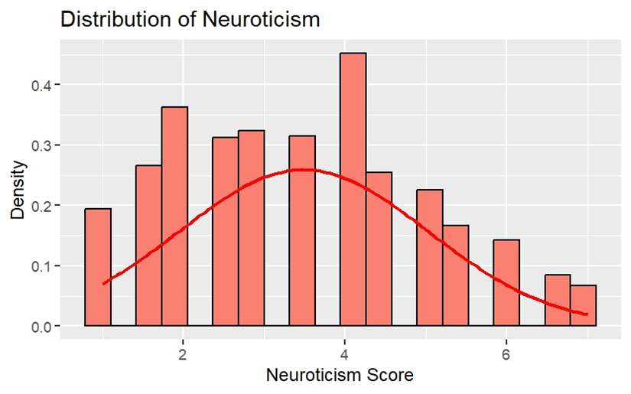
Figure 2
Distribution of Extraversion Scores
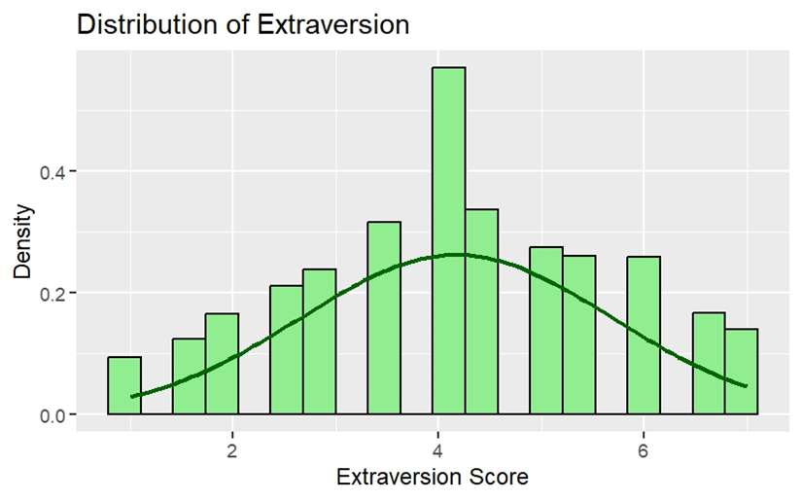

Figure 3
Distribution of Satisfaction with Life Scores
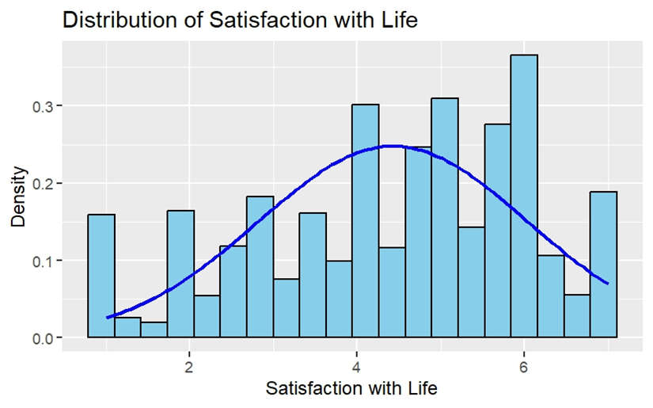
Relationships Between Personality Traits and Satisfaction with Life
To visually examine the bivariate relationships between personality traits and life satisfaction, scatterplots were generated for Extraversion and Neuroticism in relation to Satisfaction with Life (Figures 4 and 5). As shown in Figure 4, Extraversion was positively associated with Satisfaction with Life. Individuals with higher levels of Extraversion tended to report greater life satisfaction. In contrast, Figure 5 illustrates a negative association between Neuroticism and Satisfaction with Life, such that participants scoring higher on Neuroticism reported lower levels of life satisfaction.

Figure 4
Relationship between Extraversion and Satisfaction with Life
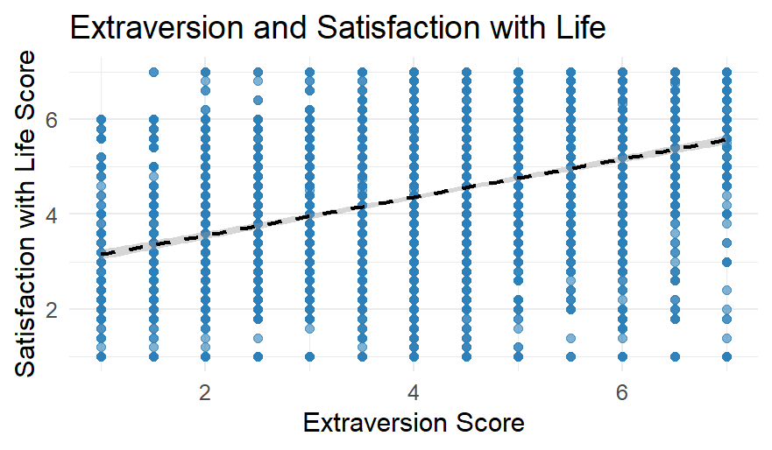
Figure 5
Relationship between Neuroticism and Satisfaction with Life.
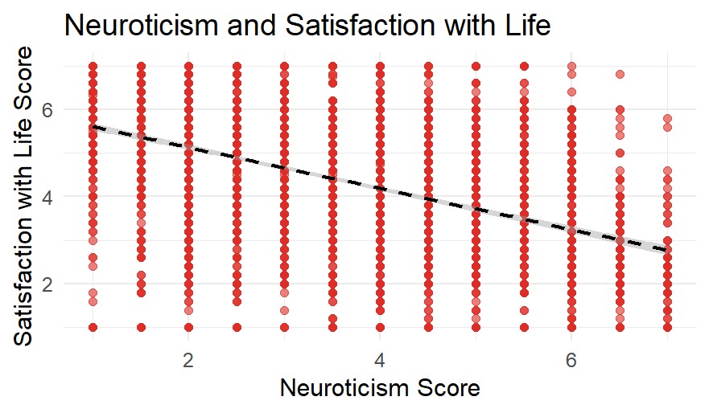

Bivariate Correlations
Table 2 presents the means, standard deviations, and bivariate Pearson correlations for the key study variables. As shown, Satisfaction with Life was positively correlated with Extraversion (r = .38, p < .001) and negatively correlated with Neuroticism (r = -.45, p < .001). Extraversion and Neuroticism were also significantly negatively correlated (r = -.33, p < .001).
Table 2
Means, Standard Deviations, and Bivariate Correlations for Key Variables
Variable | M | SD | Satisfaction  with Life | Extraversion | Neuroticism
Satisfaction  with Life | 4.43 | 1.61 | 1.00 | 0.38*** | -0.45***
Extraversion | 4.18 | 1.52 | 0.38*** | 1.00 | -0.33***
Neuroticism | 3.49 | 1.54 | -0.45*** | -0.33*** | 1.00
Values are Pearson correlations. p < .05 = *, p < .01 = **, p < .001 = ***.

Assessment of Multicollinearity
Multicollinearity among predictors was assessed using Variance Inflation Factors (VIF) and corresponding Tolerance values. As shown in Table 3, both Extraversion and Neuroticism had VIF values of 1.12, well below the commonly used threshold of 5, and Tolerance values of 0.89, indicating a low level of multicollinearity. These results suggest that the predictors do not exhibit problematic intercorrelations and are suitable for inclusion in the same regression model.

Table 3
Variance Inflation Factors (VIF) and Tolerance Values for Multicollinearity Assessment
Predictor | VIF | 1 / VIF (Tolerance)
Extraversion | 1.12 | 0.89
Neuroticism | 1.12 | 0.89

Baseline Model Results
A baseline (null) linear mixed-effects model was estimated to quantify the variance in Satisfaction with Life attributable to between-person and between-day differences. This model included a fixed intercept and random intercepts for both Participant ID and Day Measured. The model was estimated using maximum likelihood (ML) and served as the foundation for calculating the intraclass correlation coefficient (ICC).
Results indicated substantial between-person variability (Var = 1.90, SD = 1.38) and minimal between-day variability (Var = 0.003, SD = 0.06). The residual variance was 0.66 (SD = 0.81). The fixed intercept was significant (b = 4.43, SE = 0.09, t(267.46) = 50.73, p < .001). The intraclass correlation coefficient (ICC), calculated using the performance package, was 0.74, indicating that approximately 74.4% of the variance in Satisfaction with Life was attributable to differences between individuals. This high ICC supports the use of a multilevel modeling approach that accounts for nested data structure.

Model 1: Extraversion as a Predictor of Life Satisfaction
The first predictor model (Model H1) examined the effect of Extraversion on Satisfaction with Life, including random intercepts for Participant ID and Day Measured. This model was estimated using maximum likelihood (ML) estimation. Extraversion was a significant positive predictor of life satisfaction (b = 0.23, SE = 0.01, t(4,150) = 19.48, p < .001), indicating that individuals who scored higher on Extraversion tended to report higher daily satisfaction with life.

Model 2: Neuroticism as a Predictor of Life Satisfaction
The second predictor model (Model H2) evaluated the effect of Neuroticism on Satisfaction with Life, while including random intercepts for Participant ID and Day Measured. The model was estimated using maximum likelihood (ML) estimation. Neuroticism was a significant negative predictor of life satisfaction (b = -0.27, SE = 0.01, t(4,152) = -24.89, p < .001), indicating that individuals who scored higher on Neuroticism reported significantly lower levels of daily life satisfaction.

Model 3: Combined Effects of Extraversion and Neuroticism
Model H3 included both Extraversion and Neuroticism as fixed effects, along with random intercepts and random slopes for both predictors at the levels of Participant ID and Day Measured. This model was estimated using maximum likelihood (ML) and represents the most complex model tested in the current analysis. Extraversion remained a significant positive predictor (b = 0.16, SE = 0.02, t(204.56) = 10.51, p < .001), and Neuroticism also remained a significant negative predictor (b = -0.21, SE = 0.02, t(167.72) = -12.04, p < .001). The intercept was significant as well (b = 4.51, SE = 0.12, t(180.61) = 37.37, p < .001).

Model Comparison: H1 vs. H3
To evaluate whether the more complex random slopes model (Model H3) provided a better fit than the simpler Extraversion-only model (Model H1), a likelihood ratio test was conducted using the anova() function. Model H1 included Extraversion as a fixed effect with random intercepts, while Model H3 included both Extraversion and Neuroticism with random slopes and intercepts across participants and days. See table 4.
The likelihood ratio test indicated a significant improvement in model fit for Model H3 over Model H1, χ²(11) = 597.37, p < .001. This suggests that the added complexity of including both predictors and modeling their random slopes significantly enhanced the explanatory power of the model. These results support the joint and interactive contribution of Extraversion and Neuroticism in predicting daily satisfaction with life. Table 4 presents a comparison of Model H1 (Extraversion only) and Model H3 (Full model including Extraversion and Neuroticism with random slopes).
Table 4
Model Comparison Between Model H1 and Model H3
Model | Parameters  (npar) | AIC | BIC | LogLik | Deviance | Chi-square (df), p
Model H1 | 5.00 | 10933.00 | 10965.00 | -5461.40 | 10923.00
Model H3 | 16.00 | 10358.00 | 10459.00 | -5162.70 | 10326.00 | 597.37 (11), p < .001

Model Comparison: H2 vs. H3
A second model comparison was conducted to evaluate whether Model H3 also provided a significantly better fit than the Neuroticism-only model (Model H2). While Model H2 included Neuroticism as a fixed effect and random intercepts for participants and days, Model H3 incorporated both Extraversion and Neuroticism as fixed effects along with random slopes for both predictors across participants and days.
The likelihood ratio test comparing these models revealed that Model H3 significantly improved model fit over Model H2, χ²(11) = 383.70, p < .001. This supports the conclusion that adding Extraversion and allowing both predictors to vary across units substantially enhances the model's explanatory power. Together, these comparisons underscore the value of jointly modeling both personality traits with appropriate random effects structures in predicting daily life satisfaction. Table 5 compares Model H2 (Neuroticism only) and Model H3.
Table 5
Model Comparison Between Model H2 and Model H3
Model | Parameters  (npar) | AIC | BIC | LogLik | Deviance | Chi-square (df), p
Model H2 | 5.00 | 10719.00 | 10751.00 | -5354.60 | 10709.00
Model H3 | 16.00 | 10358.00 | 10459.00 | -5162.70 | 10326.00 | 383.70 (11), p <.001
Based on the likelihood ratio tests and model fit statistics presented in Tables 4 and 5, Model H3 was selected as the final model. It demonstrated significantly better fit compared to both Model H1 and Model H2, as evidenced by lower AIC and BIC values and highly significant chi-square tests. Furthermore, Model H3 accounts for both Extraversion and Neuroticism as fixed effects and allows their effects to vary across individuals and days.

Residual Diagnostics for the Final Model
Residual diagnostics were conducted for the final selected model (Model H3) to evaluate key assumptions of linear mixed-effects modeling. These diagnostics included a histogram of residuals, a residual dependence plot (residuals vs. fitted values), and a spread-location plot. Each of these plots offers insights into the appropriateness of the model for inference.
The histogram of residuals (see Figure 6) indicated a roughly normal distribution, with residuals centered around zero. This supports the assumption of normally distributed errors, which is essential for obtaining valid standard errors and confidence intervals in mixed-effects modeling. The residual dependence plot showed no strong curvature, although a slight funnel-shaped pattern was observed. This suggests the presence of minimal heteroscedasticity, where residual variance appears greater at lower fitted values. Such a pattern could impact standard error estimation and may warrant the use of robust estimation techniques. The spread-location (S-L) plot further confirmed this pattern, with absolute residuals increasing slightly at lower fitted values. This trend supports the conclusion of mild non-constant variance, which should be considered when interpreting model results. Despite these deviations, the model assumptions are reasonably met and given the large sample size and the robustness of linear mixed-effects models, the impact of minor violations is expected to be minimal. In addition, an Autocorrelation function(ACF) plot of the model residuals (Figure 7) was examined to assess residual autocorrelation, particularly relevant in longitudinal or repeated-measures data. The plot showed no significant autocorrelations beyond lag 0, indicating that the model has adequately accounted for the temporal dependence structure.

Figure 6
Residual histogram, residuals vs. fitted, and spread-location plots for Model H3.
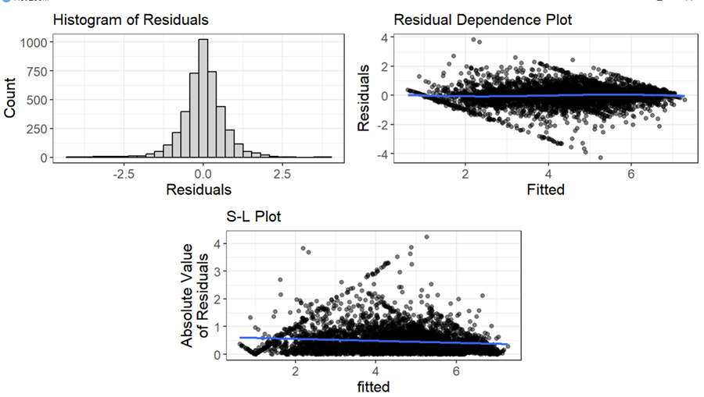]
Figure 7
Autocorrelation function (ACF) plot of residuals from Model H3
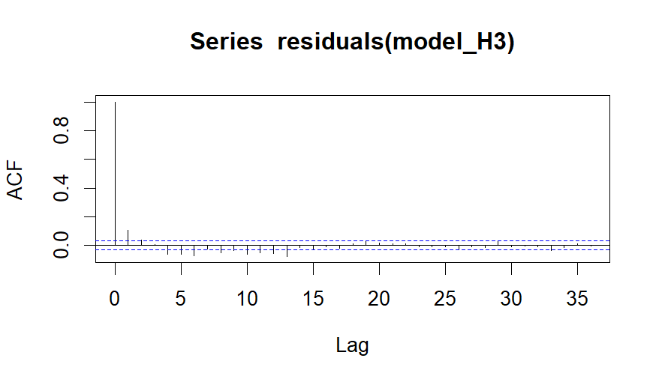

Estimates for Final Model
Table 6 displays the fixed effects estimates from the final linear mixed-effects model (Model H3), which includes Extraversion and Neuroticism as predictors of Satisfaction with Life. All fixed effects were statistically significant at p < .001, and their 95% confidence intervals did not include zero, indicating reliable and meaningful associations. The intercept of 4.51 represents the expected level of life satisfaction when Extraversion and Neuroticism are held at zero. Higher Extraversion was associated with increased life satisfaction (b = 0.16), while higher Neuroticism was associated with reduced life satisfaction (b = -0.21).
Table 6
Fixed Effects with 95% Confidence Intervals and p-values
Parameter | Estimate | SE | 95% CI (Lower) | 95% CI (Upper) | p-value
(Intercept) | 4.51 | 0.12 | 4.28 | 4.75 | < .001
Extraversion | 0.16 | 0.02 | 0.13 | 0.19 | < .001
Neuroticism | -0.21 | 0.02 | -0.25 | -0.18 | < .001

Model Performance Metrics
To evaluate the overall performance of the final model (Model H3), we report several key fit indices, including the Intraclass Correlation Coefficient (ICC), marginal R², and conditional R². These metrics are presented in Table 7. The ICC value of 0.77 indicates that a substantial proportion of the variance in life satisfaction (77%) can be attributed to differences between participants. The marginal R², representing the variance explained by the fixed effects alone, was 0.10, while the conditional R², which accounts for both fixed and random effects, was 0.79. This suggests that random effects contributed substantially to the explanatory power of the model.
Table 7
Model Fit Indices for Final Model (Model H3)
Metric | Value
Intraclass Correlation Coefficient (ICC) | 0.77
R² Marginal (Fixed Effects) | 0.10
R² Conditional (Fixed + Random Effects) | 0.79

Discussion
This study examined how personality traits—specifically Extraversion and Neuroticism—predict daily satisfaction with life using a multilevel modeling approach that accounts for both individual differences and daily fluctuations. The results revealed that individuals who scored higher on Extraversion tended to report greater satisfaction with life, whereas those who scored higher on Neuroticism reported lower life satisfaction. These findings held even when accounting for repeated measurements within individuals and across days. Extraversion and Neuroticism each explained unique portions of the variance in well-being.
Our first hypothesis (H1) that Extraversion would be positively associated with satisfaction with life was supported. Extraversion was a significant positive predictor of daily life satisfaction (b = 0.161, p < .001). Participants with higher levels of Extraversion consistently reported greater satisfaction with life. This relationship held across repeated measurements and contributed uniquely to variance in well-being.
Our second hypothesis (H2) that Neuroticism would be negatively associated with satisfaction with life was also supported. Neuroticism was a significant negative predictor of life satisfaction (b = -0.212, p < .001). Higher Neuroticism scores were associated with lower daily life satisfaction, reflecting the well-documented link between emotional instability and reduced well-being.
Our third hypothesis (H3) that the effects would be similar for both level 1 (within participants over time) and level 2 (between participants) was partially supported. The use of a random slopes model (Model H3) revealed significant variability in the effects of both Extraversion and Neuroticism across participants and days. This suggests that while the overall direction of the effects was consistent (positive for Extraversion, negative for Neuroticism), the strength of these associations differed between individuals and across time. Thus, the fixed effects held consistently, but the random slopes indicate meaningful person-level and day-level variation.

Limitation

While this study offers valuable insights into how personality traits influence daily life satisfaction, several limitations should be noted. First, the final multilevel model showed signs of a singular fit, suggesting that one or more variance components were estimated near zero. This may result from an overparameterized model or weak random slopes. Although fixed effects were significant, caution is warranted when interpreting the random effect’s structure.
Second, analysis of missing data revealed eight missing values (0.19% of the total 4,252 observations), distributed across day (1), satisfaction with life (1), Extraversion (3), and Neuroticism (3) variables. Hower, this will result in minimal loss of power. The mixed-effects model, when assuming Missing at Random (MAR), can handle missing data effectively by using the Maximum Likelihood Estimation (MLE) approach. Mixed-effects models (lmer in R) can handle missing data under the assumption of Missing at Random (MAR). These models use all available data points and account for the structure of the data. Little's Missing Completely at Random (MCAR) Test. This test evaluates whether the missing data is MCAR. It compares the means of observed and missing data across variables. Specifically, in R, you can use the naniar package to perform Little's MCAR test: The test rejects the null hypothesis that the data is MCAR. The missing data may be MAR or Missing Not At Random (MNAR). The analysis was conducted under the assumption of MAR which is automatically applied to to lmer models using MLE in R. The results of Little’s MCAR test indicate that the data are not missing completely at random. The test produced a statistic of 10.60 with 4 degrees of freedom and a p-value of 0.032.
Third, diagnostic plots indicated minimal heteroscedasticity, with residuals showing greater variance at lower fitted values. While residuals were approximately normal and linearity held, the non-constant variance may affect standard error accuracy. Future models could use robust estimation methods e.g., Bootstrap Standard Errors with unbiased and representative samples.
Future research should refine model complexity to avoid convergence issues, consider multiple imputations for missing data. Additionally, future research could utilize nonlinear Mixed-Effects Models, e.g., the nlme package in R since it allows for more flexibility in capturing complex relationships.

Conclusion
In summary, this study highlights the important role of personality traits—specifically Extraversion and Neuroticism—in shaping daily life satisfaction. Individuals who are more outgoing and enthusiastic tend to report higher well-being, while those who are more emotionally reactive experience lower satisfaction. These associations remained consistent across time and individuals, suggesting that personality exerts a stable influence on daily well-being.

